**General Scholarship Search Engines**

[**www.gacollege411.org**](http://www.gacollege411.org)

[**www.bigfuture.collegeboard.org**](http://www.bigfuture.collegeboard.org)

[**www.scholarships.com**](http://www.scholarships.com)

[**www.uncf.org**](http://www.uncf.org)

[**https://www.myscholly.com/**](https://www.myscholly.com/)

[**https://www.salliemae.com/**](https://www.salliemae.com/)

[**www.latinocollegedollars.org**](http://www.latinocollegedollars.org)

[**www.finaid.org**](http://www.finaid.org)

[**www,petersons.com/finaid**](http://www.petersons.com/finaid)

[**www.hispanicfund.org**](http://www.hispanicfund.org)

**Scholarship Tips for High School Students**

**#1– Make The Community Connection –** Many students spend a lot of time focusing on national scholarship opportunities, but local scholarships can truly be a goldmine. There are a host of local professional associations such as the New York Association of Blacks in Energy, the National Association of Hispanic Journalists, and the New York Association of Legal Administrators that offer local scholarship opportunities. Local chapters of the Urban League Young Professionals, sororities, fraternities, and even local credit unions are also often untapped resources.

**#2 – Keep It Personal-** The most lucrative scholarship opportunities are by far the ones directly connected to your personal experiences, family backgrounds and organizational involvement. Make a list of unique characteristics, memberships and parent affiliations to enhance your scholarship list.



**30 Georgia-Specific Scholarship Opportunities**

1. Watson-Brown Foundation [www.watson-brown.org](http://www.watson-brown.org)
2. MidSouth Federal Credit Union www.midsouthfcu.org
3. Horatio Alger Georgia Scholarship www.horatioalger.org
4. Omega Psi Phi Fraternity, Inc.- [www.highaspirationsfoundation.org](http://www.highaspirationsfoundation.org)
5. Atlanta Alumnae Panhellenic Association [www.atlantapanhellenic.org](http://www.atlantapanhellenic.org).
6. Georgia Business Aviation Association Scholarship [www.gbaa.org](http://www.gbaa.org)
7. Georgia Federal Credit Union Scholarship [www.gfcuonline.org](http://www.gfcuonline.org),
8. The Wayne Reynolds Scholarship [www.reynoldsscholarship.org](http://www.reynoldsscholarship.org)
9. BBB's 2010 Student of Integrity [www.atlanta.bbb.org](http://www.atlanta.bbb.org)
10. Georgia Farm Bureau Scholarship for Agriculture [www.gfb.org](http://www.gfb.org)
11. Corinne Jeannine Schillings Foundation Scholarship [www.cjsfoundation.org](http://www.cjsfoundation.org)
12. MetroPCS Community Scholars Program [www.metropcs.com/scholarship](http://www.metropcs.com/scholarship)
13. Univision 34’s Liga de Campeones Scholarship [www.newtoncountyschools.org/documents](http://www.newtoncountyschools.org/documents)
14. Georgia Teen Mothers Scholarship [www.gateenmotherscholarship.org](http://www.gateenmotherscholarship.org)
15. The Atlanta Association of Legal Administrator’s Gene Henson Scholarship [www.atlanta-ala.com](http://www.atlanta-ala.com).
16. Jackson EMC Youth Citizenship Award [www.jacksonemc.com/citizenship](http://www.jacksonemc.com/citizenship)
17. Georgia Association of Educators Foundation www.neageorgia.org
18. Walton EMC Scholarship Fund “Operation Round Up [www.waltonemc.com](http://www.waltonemc.com)
19. Xernona Clayton Scholarship [www.aabj.org](http://www.aabj.org)
20. Georgia Fire Sprinkler Association Scholarship [www.georgiafiresprinkler.org/contest.php](http://www.georgiafiresprinkler.org/contest.php)
21. Gwinnett Federal Credit Union Student Scholarship www.gwinnettfcu.org
22. LULAC (Atlanta Council No. 950) Scholarship [www.lulacatl950.org](http://www.lulacatl950.org)
23. Katherine Snorton Scholarship Program www.theleadfoundation.org
24. Julian & Jan Hester Memorial Scholarship Fund [www.cbaofga.com/marketing/hester-scholarship.php](http://www.cbaofga.com/marketing/hester-scholarship.php)
25. American Association of Blacks in Energy Atlanta Chapter Scholarship [www.aabe.org](http://www.aabe.org)
26. APPEAL Foundation Scholarship [www.iotazetasigmasgr.org](http://www.iotazetasigmasgr.org).
27. Ron Daniels Scholarship [www.atlantasmta.com/scholarship.html](http://www.atlantasmta.com/scholarship.html)
28. RKL Education Foundation Scholarship [www.rklef.org](http://www.rklef.org)
29. Charlotte Lemons Annual Students Scholarship [www.madf.org](http://www.madf.org)
30. Vincent J. Dooley Award [www.abw.org/dooleyscholarship/index.asp](http://www.abw.org/dooleyscholarship/index.asp)

**Sometimes The Answer *Is* Literally Right Under Your Nose.**

50 Hurt Plaza, Suite 860

Atlanta, GA 30303

Phone: 470-355-1732

E-mail address: jessica@scholarshipacademy.org

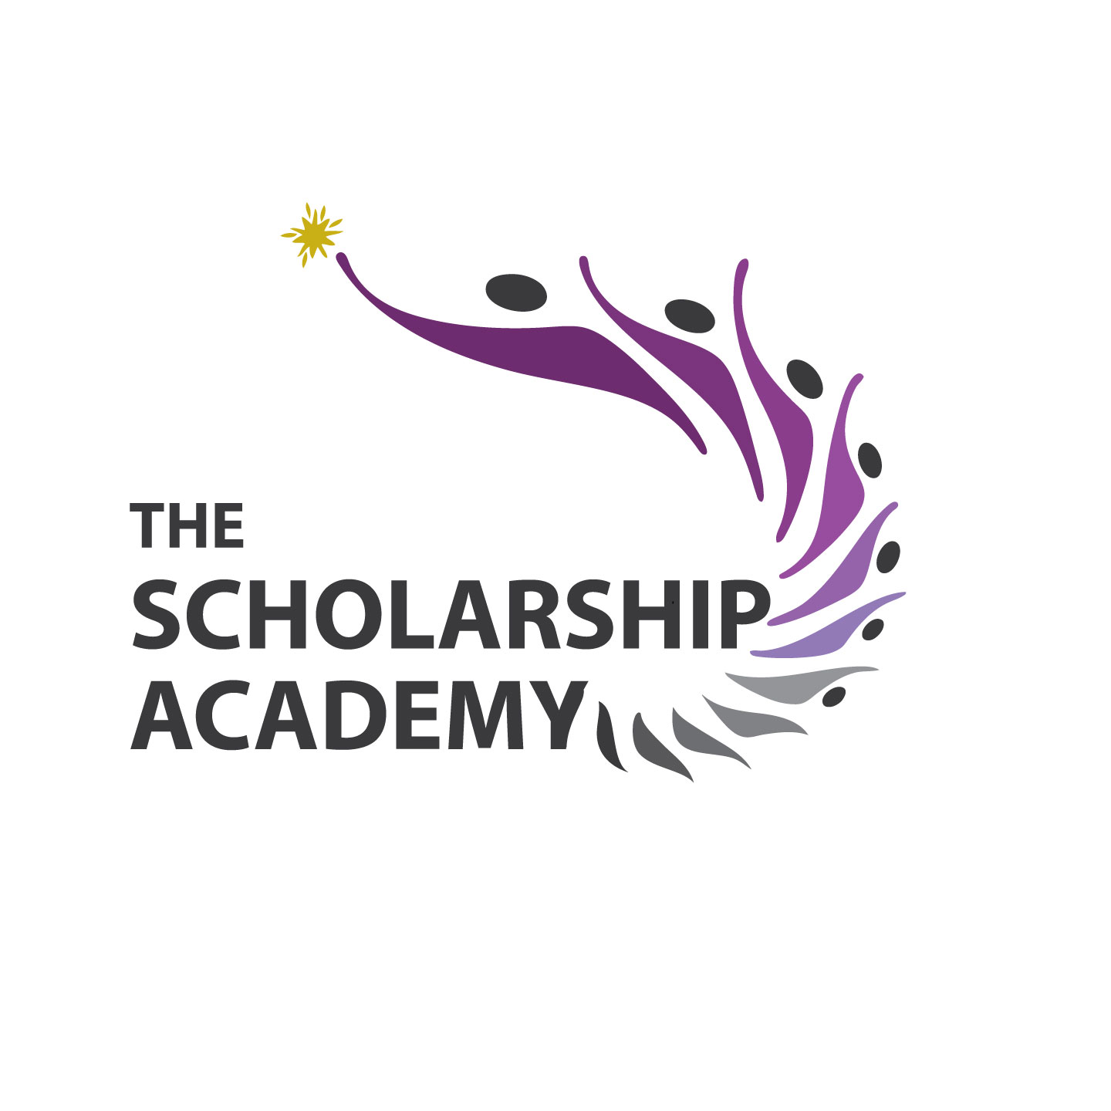

# Popular Scholarship Search Engines